Maven Build Life Cycle
What is build life cycle? The sequence of steps which is defined in order to execute the tasks and goals of any maven project is known as build life cycle in maven. Maven 2.0 version is basically a build life cycle oriented and clearly says that these steps are well defined to get the desired output after the successful execution of the build life cycle.
Maven comes with 3 built-in build life cycles as shown below :
- Clean - this phase involves cleaning of the project (for a fresh build & deployment)
- Default - this phase handles the complete deployment of the project
- Site - this phase handles the generating the java documentation of the project.
Now we will dig more into the detailed phases involved in the above mentioned built-in build life cycles.

Build Life Cycle of clean phase
As mentioned above, this clean phase is used to clean up the project and make it ready for the fresh compile and deployment. The command used for the same is mvn post-clean. When this command is invoked, maven executes the below tasks via executing the below commands internally :
- mvn pre-clean
- mvn clean
- mvn post-clean
This maven's clean is a goal and on executing it cleans up the output directory (target folder) by deleting all the compiled files.
NOTE : whenever a maven command for any life cycle is invoked, maven executes the phases till and up to the invoked phase. E.g. when 'mvn clean' is invoked, maven will execute only the phase clean. But, no compile/deployment/site phase is invoked.
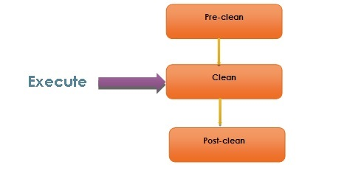

Build Lifecycle (Default)
Below is the list of phases in the build lifecycle (default) of maven. These phases will be invoked through the maven commands.
Lifecycle Phase | Description
validate | Validates and ensures that the project is fine and perfect considering all the required information is made available for the build
generate-sources | Generating any source code to include the same in the compilation process
process-sources | Processing the source code in case some filter needs to be applied
generate-sources | Generating any source code to include the package
process-resources | Process of copying the resources to the destination folder and getting ready for the packaging
compile | Compilation of the project source code.
process-classes | To perform the bytecode enhancements for the class files generated from the compilation
generate-test-sources | Copying and processing the resources in the test destination directory.
test-compile | Compile the source code in the test destination directory
test | Executing/running the tests using some suitable test framework. Note: these test cases are not considered for packaging and deploying
prepare-package | To perform any final changes/validations before it is sent for final packaging.
package | Packaging the successfully compiled and tested code to some distributable format - JAR, WAR, EAR
pre-integration-test | To perform actions before integration tests are executed. This may require to set up some environmental changes for the app.
integration-test | Deploy the application to an environment where integration tests can be run.
post-integration-test | Basically, cleaning up the environment which was made in pre-integration-test phase.
verify | Performs action for a quality check and ensures the required criteria being met
install | Installing the application in the local repository. Any other project can use this as a dependency.
deploy | The final package will be copied to a remote repository, may be as a formal release and also made available to the other developers too.

Site Lifecycle (site)
Apart from cleaning, compiling the source code, building a deployable format of the application, maven has phase which does more than these phases. This phase is one of the vital features provided by maven which generates the detailed documentation of any java project.
This project documentation has a dedicated phases involved as listed below :
- pre-site
- site
- post-site
- site-deploy
The command used in maven to generate javadocs for a given project is 'mvn site'. Basically, when this command is invoked, maven calls 'Doxia' document generation and other report generating plugins.
Doxia is basically a framework used for content generation by maven. This generates contents both in static and dynamic ways.
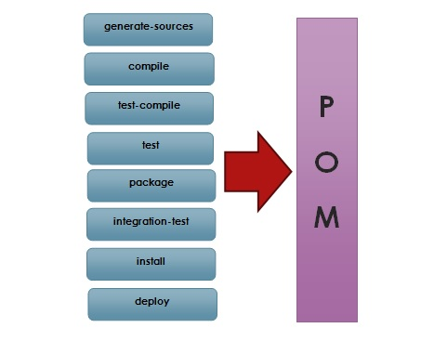

Build Profiles in Maven
Profile in maven is nothing but subset of elements which allows to customize builds for particular environment. Profiles are also portable for different build environments.
Build environment basically means a specific environment set for production and development instances. When developers work on development phase, they are intend to use database from the production instance and for the production phase, the live database will be used.
So, in order to configure these instances maven provides the feature of build profiles. Any no. of build profiles can be configured and also can override any other settings in the pom.xml
These defined profiles have the ability to modify the pom.xml during the build time. I.e. to configure separate environments for development and production instances. Based on the parameters passed, the corresponding profiles are activated accordingly. E.g. profiles can be set for dev, test and production phases.

Types of build profiles
The below table shows the types of build profiles in Maven :
Build Profile Type | Defined in
Per project | pom.xml
Per User/Developer | Maven settings.xml (%USER_HOME%/.m2/settings.xml)
Global | Maven global settings.xml (%M2_HOME%/conf/settings.xml)

Build Portability
As mentioned above, different environments can be set up based on the requirements for a given project. So, with this the portability of a given project can be secured and handled effectively.
Build portability can be defined as the ability of a project which can be compiled and deployed successfully across different set of environments which also involves the applying different environmental configurations for the same. Any portable project should always tend to work without any customization of any properties.
And Any portable project will always eliminates the complexities and issues associated to contributing to a project.

Activating profiles
Below are ways in which build profiles of maven can be activated or triggered :
- Explicitly using commands
- Maven settings
- Based on environment variables
- Operating system settings
- Present/missing files

Explicitly using commands
<profiles>
<profile>
<id>test</id>
<build>
<plugins>
<plugin>
<groupId>org.apache.maven.plugins</groupId>
<artifactId>maven-antrun-plugin</artifactId>
<version>1.1</version>
<executions>
<execution>
<phase>test</phase>
<goals>
<goal>run</goal>
</goals>
<configuration>
<tasks>
<echo>Using app.test.properties</echo>
<copy file="src/main/resources/app.test.properties"
tofile="${project.build.outputDirectory}/env.properties"/>
</tasks>
</configuration>
</execution>
</executions>
</plugin>
</plugins>
</build>
</profile>

Maven Settings
<settings xmlns="http://maven.apache.org/POM/4.0.0"
xmlns:xsi="http://www.w3.org/2001/XMLSchema-instance"
xsi:schemaLocation="http://maven.apache.org/POM/4.0.0
http://maven.apache.org/xsd/settings-1.0.0.xsd">
<mirrors>
<mirror>
<id>com.testorg.companyname</id>
<name>Internal Artifactory Maven repository</name>
<url>http://repo1.maven.org/maven2/</url>
<mirrorOf>*</mirrorOf>
</mirror>
</mirrors>
<activeProfiles>
<activeProfile>test</activeProfile>
</activeProfiles>
</settings>

Based on Environment Variables
<profile>
<id>test</id>
<activation>
<property>
<name>env</name>
<value>test</value>
</property>
</activation>
</profile>

Operating System Settings
<profile>
<id>test</id>
<activation>
<os>
<name>Windows 7</name>
<family>Windows</family>
<arch>x86</arch>
<version>5.1.2600</version>
</os>
</activation>
</profile>

Present/missing files
<profile>
<id>test</id>
<activation>
<file>
<missing>
target/generated-sources/axistools/wsdl2java/com/orgname/group
</missing>
</file>
</activation>
</profile>

Maven Plugins
Plugin in maven is the one of the vital feature that is basically used to reuse the common build logic across different projects. Plugins are the ones through which all the tasks like compiling code, testing them with the junits, creating jar/war/ear files and documentation of the projects are carried out. Most of the work in maven is done using plugins, since the dependencies (jar files) are added only to the classpath while executing tasks.
So, maven is nothing but a plugin execution framework in which every tasks are accomplished by the usage of plugins.
Below are the basic list of tasks that are handled by plugins in maven :
- Creating jar/war/ear files.
- Code compilation
- Unit testing of the code.
- Project documentation
Behavior of any plugin can be changed using a set of parameters exposed by each plugin goal (also known as Mojo). A Mojo in maven is just a goal, basically specifies the metadata of a goal - goal name, which phase it fits into and parameters expected by the goal.

Types of Plugins
Basically 2 important types of plugins exist in maven as listed below :
- Build Plugins - Basically these plugins will execute during the build phase. These plugins are defined under the <build> element in pom.xml
- Report Plugins - These plugins are executed during the site generation (report or javadocs generation) phase. These plugins will be configured under the <reporting> element in pom.xml

Some Common Plugins
Below are list of commonly used plugins in any java projects built using maven :
Plugin name | Description
clean | Used to delete the target directory in order to clean up the earlier build artifacts
compiler | To compile java source files
surefile | Executes the Junit tests and generate the reports.
jar | Build the jar file of the project
war | Build the war file of the project
javadoc | Generates the javadocs of the project
antrun | Runs a set of ant tasks specified in any stage/phase of the build

Sample plugin in pom.xml
<project xmlns="http://maven.apache.org/POM/4.0.0"
xmlns:xsi="http://www.w3.org/2001/XMLSchema-instance"
xsi:schemaLocation="http://maven.apache.org/POM/4.0.0
http://maven.apache.org/xsd/maven-4.0.0.xsd">
<modelVersion>4.0.0</modelVersion>
<groupId>com.orgname.orggroup</groupId>
<artifactId>project</artifactId>
<version>1.0</version>
<build>
<plugins>
<plugin>
<groupId>org.apache.maven.plugins</groupId>
<artifactId>maven-antrun-plugin</artifactId>
<version>1.1</version>
<executions>
<execution>
<id>id.clean</id>
<phase>clean</phase>
<goals>
<goal>run</goal>
</goals>
<configuration>
<tasks>
<echo>Clean Phase</echo>
</tasks>
</configuration>
</execution>
</executions>
</plugin>
</plugins>
</build>
</project>
- Each plugin can have more than one goals to perform different set of tasks accordingly.
- Starting phase of any plugin can be defined.
- Tasks can be configured associated to each goal of the plugin defined.

Benefits of Maven Plugins
- More detailed and well architecture.
- A managed life cycle
- Implementation of multiple languages
- Reusability of the common build logic.
- Ability to write maven plugins completely in java

Creating your First Project in Maven
In the earlier lessons, we have seen about the maven project architecture and the different configurations involved for a project. Now, we will understand how a sample Java project can be created using Maven. Maven can also be used to build and manage projects developed using C#, Ruby, Scala and few other languages. But, this is primarily used for java projects, so we will be using Java for examples. Also, we will see how the project is structured when created using maven.

Archetype
Maven uses archetype to create any project. Archetype is nothing but the tool provided by the maven to create a project. It is also defined as 'an organizational pattern from which all other things of the similar kind are made'.
Using archetypes provides an easy and instrumental way to create projects to the developers, where the best practices are employed as per the standards defined at the organization level. Also, archetypes enables the developers to quickly create a project and start running the same within a matter of commands.
In order to create a new simple maven java project just use the maven archetype plugin in the command line. Currently there are more than 850+ maven archetypes listed out in order to create projects under different frameworks like struts, spring, hibernate, web services (RESTful/SOAP) and many others.
So, let us create one simple project in maven. Open the command prompt and navigate to the workspace folder in your local machine (E.g. D:\Java\workspace). You can create the Workspace folder wherever you want on your PC or use your Workspace, if already created. Then type the below maven command(its a single line command) and press enter.
mvn archetype:generate -DgroupId=com.java.samples -DartifactId=JavaSamples
-DarchetypeArtifactId=maven-archetype-quickstart -DinteractiveMode=false
This maven command will create a Java project with the below details:
- groupId will be com.java.samples, representing the package.
- artifactId will be JavaSamples (on the build, JavaSamples.jar will be created)
- archetypeArtifactId is nothing but the template used for creating this Java project.
- interactiveMode is used when the developer is aware of the actual spelling of the artifact id. In the above case maven-archetype-quickstart is the one which is used and it is the proper one. If developer is not aware of this then the interactiveMode is set to be TRUE so that it will scan the remote repositories for all available archetypes. This might take longer time.
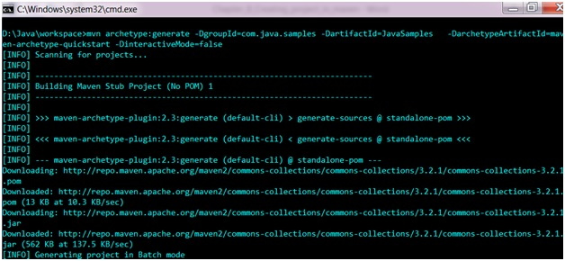
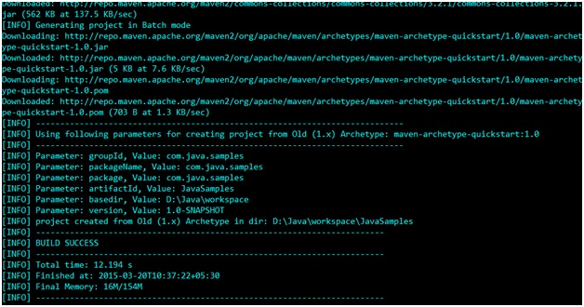
The above command instructs the maven to create a project with maven-archetype-quickstart template.
If you navigate to the folder D:\Java\workspace, a new project named JavaSamples will be created including all the base structure of a java project as well as shown below :
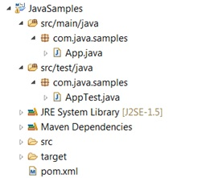
To see the following directory structure you need to Create a New Java Project on your Eclipse IDE, and import the following project there.
Table below will describe the main directories that are created as a part of the project.
Plugin name | Description
JavaSamples | Root folder of the project containing source and pom.xml
src\main\java | Contains all the java code under the package com.java.samples
src\main\test | Contains all the java test code under the package com.java.samples
src\main\resources | Contains all the resources like xml\properties file
Under the folder D:\Java\workspace\JavaSamples\src\main\java\com\java\samples a sample java file called App.java will be created by default which will be having one print statement.
package com.java.samples;

/**
* Hello world!
*
*/
public class App
{
public static void main (String[] args)
{
System.out.println("Hello World!");
}
}

And under the folder D:\Java\workspace\JavaSamples\src\test\java\com\java\samples a sample java test class (JUnit) will be created AppTest.java
package com.java.samples;
import junit.framework.Test;
import junit.framework.TestCase;
import junit.framework.TestSuite;

/**
* Unit test for simple App.
*/
public class AppTest extends TestCase{
/**
* Create the test case
*
* @param testName name of the test case
*/
public AppTest(String testName)
{
super(testName);
}

/**
* @return the suite of tests being tested
*/
public static Test suite()
{
return new TestSuite(AppTest.class);
}

/**
* Rigourous Test :-)
*/
public void testApp()
{
assertTrue(true);
}
}
The test class code which is marked as Rigorous Test is the code which is automatically generated when a sample java project is created using maven. This method will just return TRUE and the test will be passed after the run. This method is just included as one sample test. You can modify this method or add your own test methods.
Also, the TestCase class is an abstract class from the Junit API which is used here in the sample project. This will also be included by default automatically when a sample maven java project is created (check the dependency entry for junit in the pom.xml). The TestCase class defines the fixtures to run mutilple tests in a class.
Developers are required to add their files as described in the above mentioned table. They are very much free to add any new packages as well as required during the project development. The above said folder structure is just created as per the archetype plugin defined.

Versions in Maven
There are 2 major versions made available for any maven project:
- SNAPSHOT - This is nothing but the development version. New version's availability will be verified during every checkout and downloaded if it is required. This version is not allowed for releases.
- FIXED - Downloaded only once to the local repository. This is obtained whenever a major version of the software release happens.

